A Time to Give Thanks
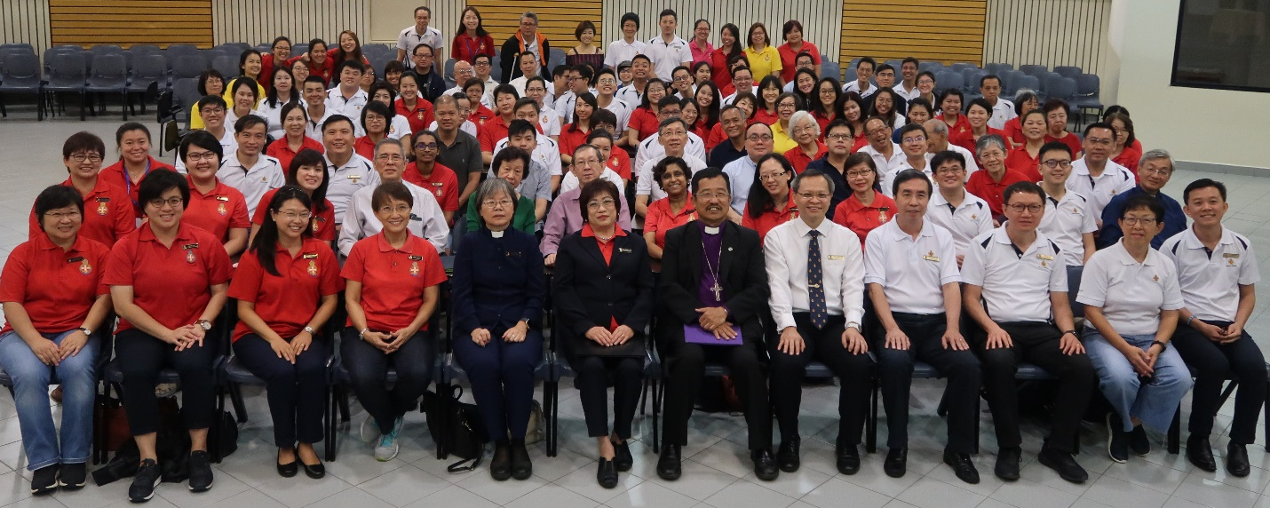

The Boys’ Brigade in Singapore (BB) and The Girls’ Brigade Singapore (GB) organised a significant inaugural joint Thanksgiving Service on 20 Oct at Christalite Methodist Chapel.
Over 100 people, including BB and GB Executive Committee Members, Officers and Alumni attended the momentous occasion.
The Right Reverend Terry Kee, President of the National Council of Churches in Singapore and Bishop of The Lutheran Church in Singapore, presided over the Service and witnessed the signing of a Memorandum of Understanding (MOU) between the two Brigades.
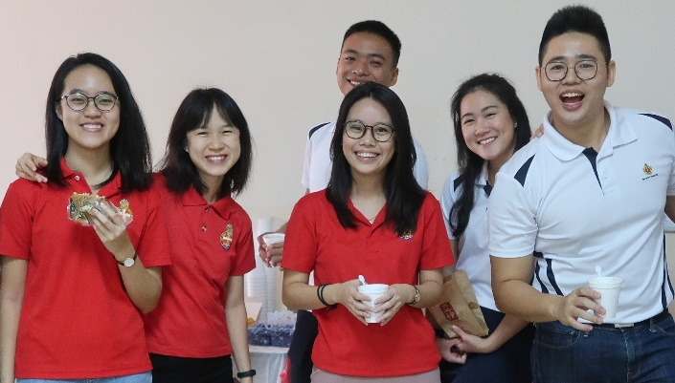 | 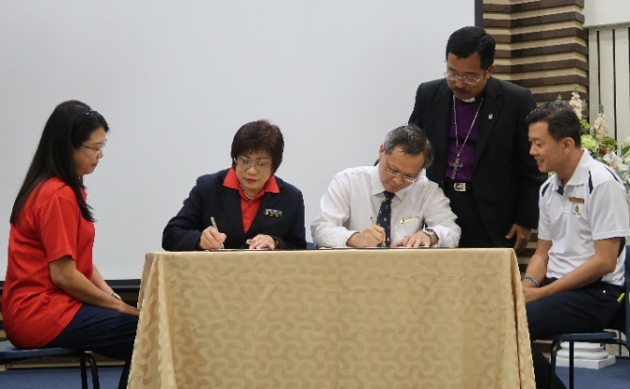
Youth BB and GB Officers enjoying a light breakfast together before the Thanksgiving Service commenced. | (From L-R) Mrs Evangeline Chong, GB Brigade Commissioner; Mrs Tay Poh Imm, GB Brigade President; Mr Poh Leong Berg, BB Brigade President; The Right Reverend Terry Kee; Mr Jason Lim, BB Brigade Secretary
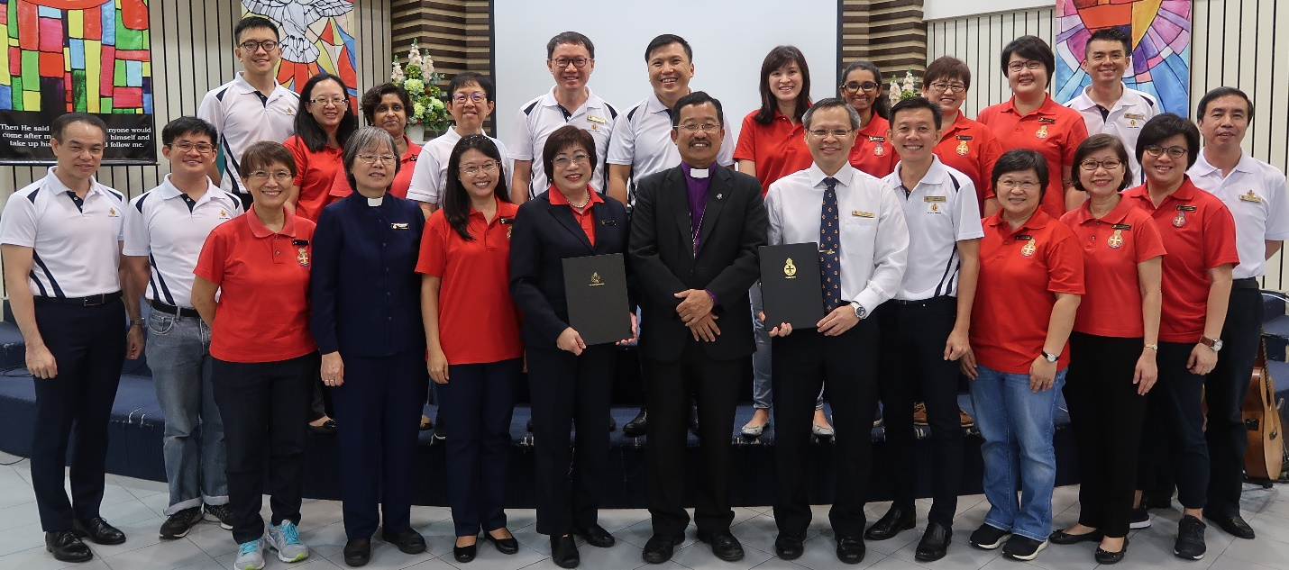
BB and GB Brigade Executive Committee Members with The Right Reverend Terry Kee after MOU Signing.
Noting the importance of Unity, the MOU focused on the BB and GB Explorers Programme.
This community development programme is developed for both Boys and Girls aged 5 through 6 (K1 and K2), catering to younger children in Singapore.
During the Service, The Right Reverend Terry Kee emphasised that the BB and GB are bound together with a common purpose and he urged the Brigades not to be daunted by differences or challenges they may face but to stand united, strengthening one another’s ministry.

